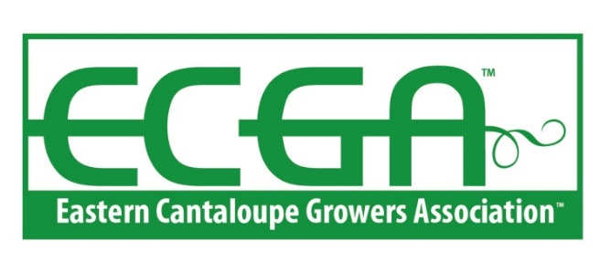

Certified Grower RENEWAL - 2022

FARM/ORGANIZATION: _____________________________________________________
PHYSICAL ADDRESS: ______________________________________________________
CITY: _______________________ STATE: ________________ ZIP: ________________
PRIMARY CONTACT: _________________________________
PHONE: __________________________ EMAIL: _________________________

Please initial and/or sign the appropriate items below and attach any required supporting documents. The information below reflects the documentation in your ECGA file:

GFSI BENCHMARKED AUDIT
Our 2021 GFSI Benchmarked Audit was conducted by ________________ and successfully passed on _______________.

***Please send in a copy of your 2021 GFSI Audit Certificate with your renewal application****

I understand that to stay in good standing as an ECGA Certified Grower Member in 2022 a renewal GFSI benchmarked audit must be successfully passed on or before ____________ and a copy of the audit certificate and report must be submitted to ECGA.
(Your Initial)

ECGA Rider to GFSI Benchmarked Audit

An ECGA Rider to the GFSI Audit was successfully passed in 2021.
(Your Initial)
I understand that to stay in good standing as an ECGA Certified Grower Member in 2022, the ECGA Rider audit must be included with the 2022 GFSI benchmarked audit and successfully passed before _______________.
(Your Initial)

ECGA Unannounced Audit

Our 2021 ECGA Unannounced Audit was conducted by ______________ and successfully passed on ______________
(Your Initial)

I understand that to stay in good standing as an ECGA Certified Grower Member in 2022 an unannounced audit must be conducted during the 2022 packing season.
(Your Initial)

ECGA Unannounced Audit – Auditor Contact Information

Please provide the information listed below so that ECGA can confirm that your farm has scheduled the 2022 Unannounced Audit. The contact information for the auditor scheduled to conduct your 2022 unannounced audit must be received by ECGA no later than Friday, May 20, 2022.
The 2022 Unannounced audit will be conducted between _________ (date) and _________ (date).
Unannounced Auditor Name: __________________________________________
Unannounced Auditor Organization: ____________________________________
Email: _____________________ Phone: ________________________________
ECGA will provide the auditor with the unannounced audit checklist upon confirming the unannounced audit has been scheduled. Please request that a copy of the audit report will be sent to ECGA within 72 hours of when the audit is conducted.

CERTIFIED MEMBER DUES:
Certified members pay a ‘Base Dues Rate’ of $500 plus an Acreage Premium as noted below. Please check your acreage range and submit the appropriate dues to ECGA when you submit this RENEWAL documentation.
Base Dues
____ 0 A to 50 A $ 100 plus $ 500 = $ 600 ______
____ 51 A to 150 A $ 300 plus $ 500 = $ 800 ______
____ 151 A to 350 A $ 700 plus $ 500 = $1,200 ______
____ 351 A to 600 A $ 1200 plus $ 500 = $1,700 ______
____ 601 A to 999 A $ 1500 plus $ 500 = $ 2,000 ______
____ Over 1000 A $ 2000 plus $ 500 = $ 2,500 ______

By signature below of our authorized representative, we certify the above information is true and accurate. We understand that ECGA is relying on our assurances that the information is true and accurate. We understand it is our responsibility to maintain our farm/facility GFSI benchmarked audit, including the ‘ECGA Rider’ standards and pass an unannounced audit. We further understand failure to successfully follow these standards, as well as any false statement in this RENEWAL APPLICATION, could result in, among other consequences, ECGA revoking our ECGA membership.
Farm/Facility: __________________________________________
Signature: _____________________________________________
Printed Name: _________________________________________
Title: _________________________________________________
Date: ____________________
SUBMIT TO: Brandi Turner, ECGA Program Coordinator at bturner@asginfo.net or

Eastern Cantaloupe Growers Association
P.O. Box 1465
LaGrange, 30241

If you have any questions regarding your 2022 ECGA Certified Grower Renewal Application, please contact Brandi Turner at bturner@asginfo.net or 706.229.7975.

